**Project Deliverable 3 – User Manual**

**Faculty Name:** Information Technology

**Module Code:** ITECA3-B12

**Module Name:** Web Development and e-Commerce

**Content Writer:** Kariboba Mpwampu

**Copy Editor:** Mr Kyle Keens

**Submission Date:** Block 2 Week 5

|  |  |
| --- | --- |
| **Student Name** | Lucinda Zachos |
| **Student Number** | Y34VR5C17 |
| **Project Title** | The Daughters of Artemis |
| **Submission Date** | 13 June 2023 |

**Table of Contents**

Table of Figures 2

3.1 Introduction 4

3.2 Basics: Accessing your website and Admin 4

3.3 Products: Adding, removing, and updating products 7

3.4 Changing menus 7

3.5 Shipping Options 7

3.6 Orders 8

3.7 Updating a page on your site 10

3.8 Collecting money from the store 10

3.9 Checking Web Traffic and Statistics 11

3.10 Appendix 11

# 

# Table of Figures

Figure 1: Guest view of cart 5

Figure 2: Registration page 5

Figure 3: Login Page for Customer and Admin 6

Figure 4: Product Management page for Admin 6

Figure 5: Guest User Menu Options 7

Figure 6: Customer User Menu Options 7

Figure 7: Admin Login Menu Options 7

Figure 8: FAQ Page 7

Figure 9: Cart Showing shipping cost 8

Figure 10: Products Page 8

Figure 11: Cart 9

Figure 12: Order Details 9

Figure 13: Database – Orders Table 10

Figure 14: Order Details – order number 10

Figure 15: Banking details 11

Figure 16: Request per minute 11

Figure 17: cPanel 12

Figure 18: File Manager 12

Figure 19: .htacess file 13

Figure 20: phpMyAdmin 14

Figure 21: Database Manager – phpMyAdmin 14

Figure 22: Database import 15

Figure 23: dbcon.php 15

# Introduction

**3.1.1 Background**

The website was designed to assist the client with selling their products online. To build an independent platform for them to conduct their business and was built to try and meet their current needs.

**3.1.2 About this website**

This website was designed to be an ecommerce website and was built utilizing a number of different technologies.

Technologies used:

* Canva for the log design
* VS Code IDE for the website’s development, which included the use of:
  + PHP,
  + CSS,
  + XML,
  + JavaScript
* Xampp for local database connection and testing.
* SQL used for storing and processing data within the database.
* phpMyAdmin for the database (MariaDb) server.
* 000webhost for hosting the website

# Basics: Accessing your website and Admin

**3.2.1 Accessing the website**

Access the website: <https://daughtersofartemis.000webhostapp.com>

Users can view the website as a guest user but will not be able to add items to cart until they have created an account. The cart button will be hidden from them.

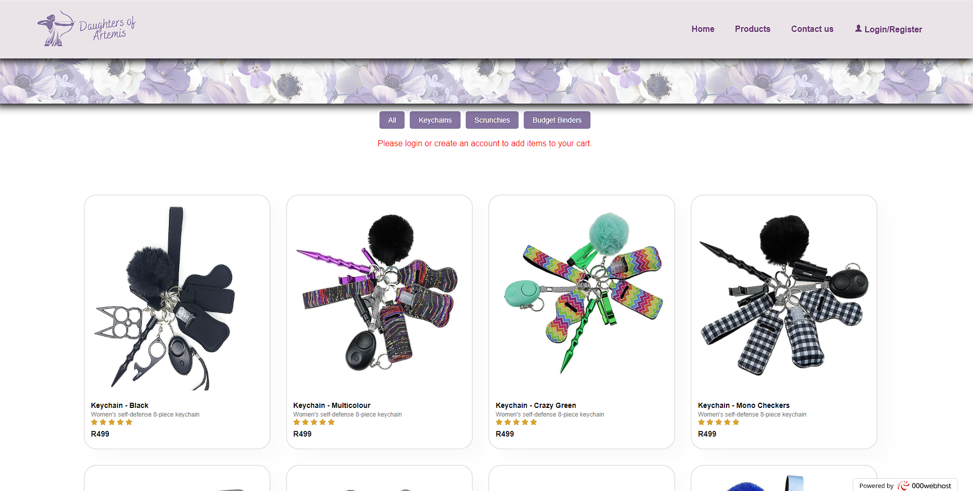

Figure 1: Guest view of cart

To create an account: <https://daughtersofartemis.000webhostapp.com/loginOrReg.php>

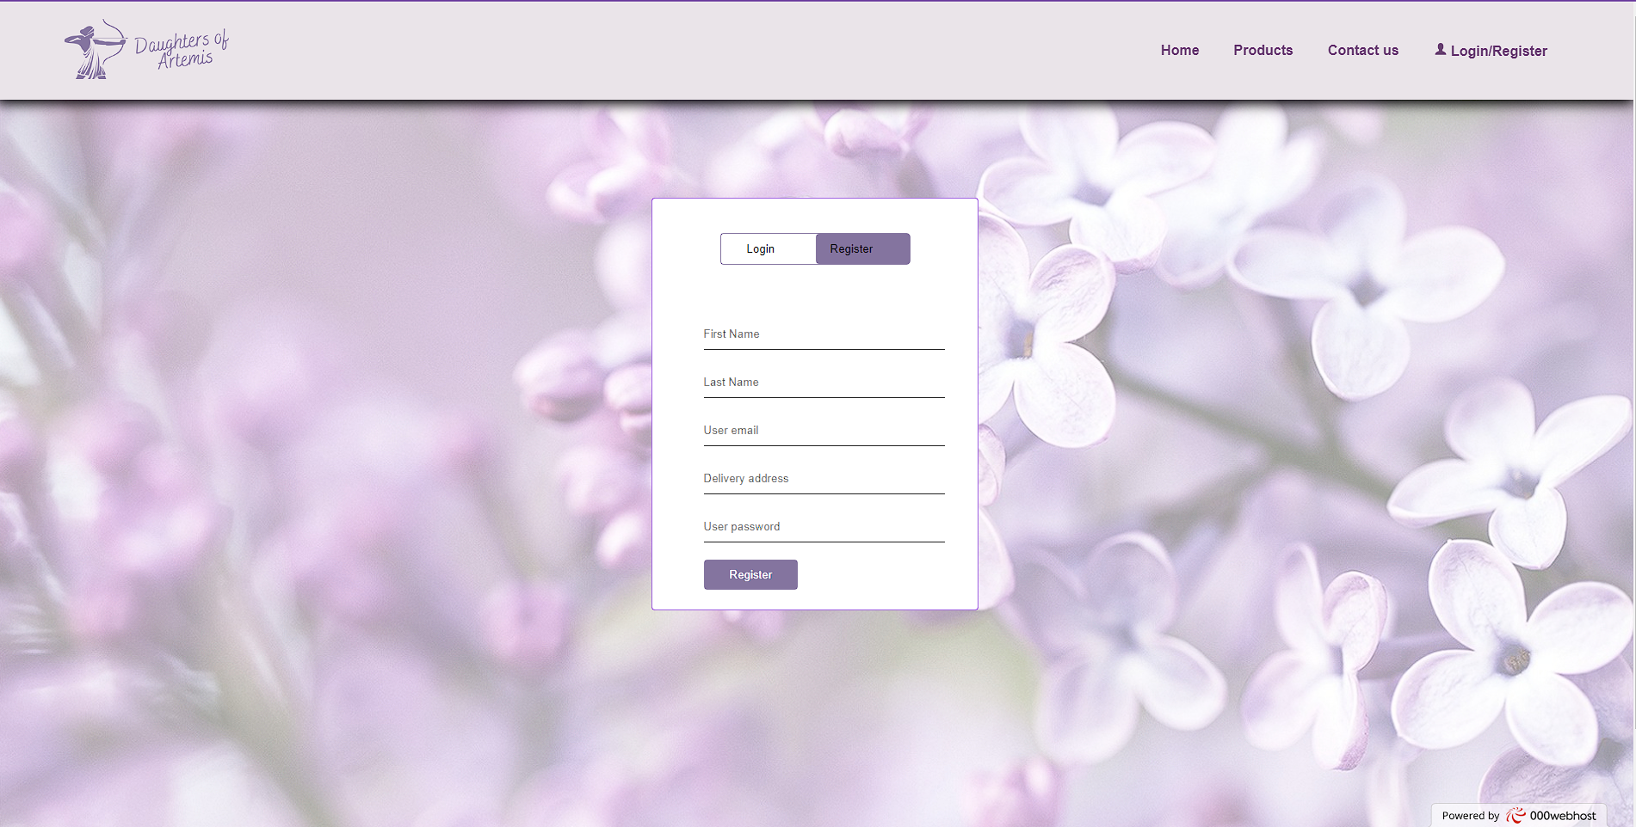

Figure 2: Registration page

Guest users can register for an account. Once registered they will be redirected to the login page where they can login using their credentials. They will then be redirected to the home page.



Figure 3: Login Page for Customer and Admin

**3.2.2 The Admin Area**

The admin area consists of a product management page for now. Once the admin logs in they can modify, add, or delete products and any changes will be updated on the database which in term will update the products page on the website.

The admin would use the standard login page and enter their email and password which has already been stored in the admin table within the database.

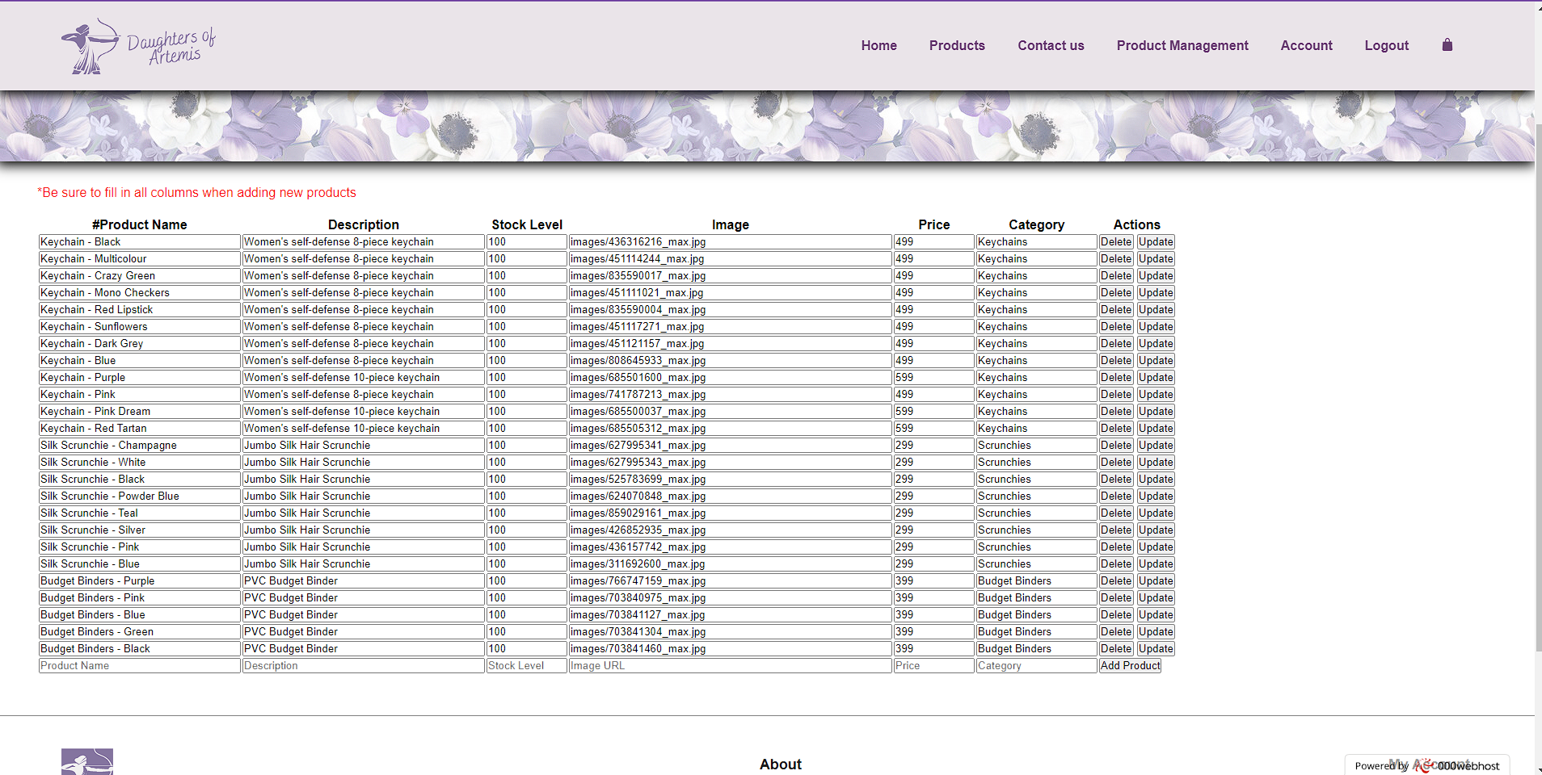

Figure 4: Product Management page for Admin

# Products: Adding, removing, and updating products

**3.3.1 Adding and Removing Products**

The admin/ seller can login with their credentials and add or delete products from the products management page using the add product button or delete button.

**3.3.2 Updating Products**

The admin/ seller can login with their credentials and update products from the products management page using the update button.

# Changing menus

The website menu depends on whether the customer is viewing as a guest or signed in as a customer, furthermore it also changes depending on whether an admin is logged in or not.



Figure 5: Guest User Menu Options

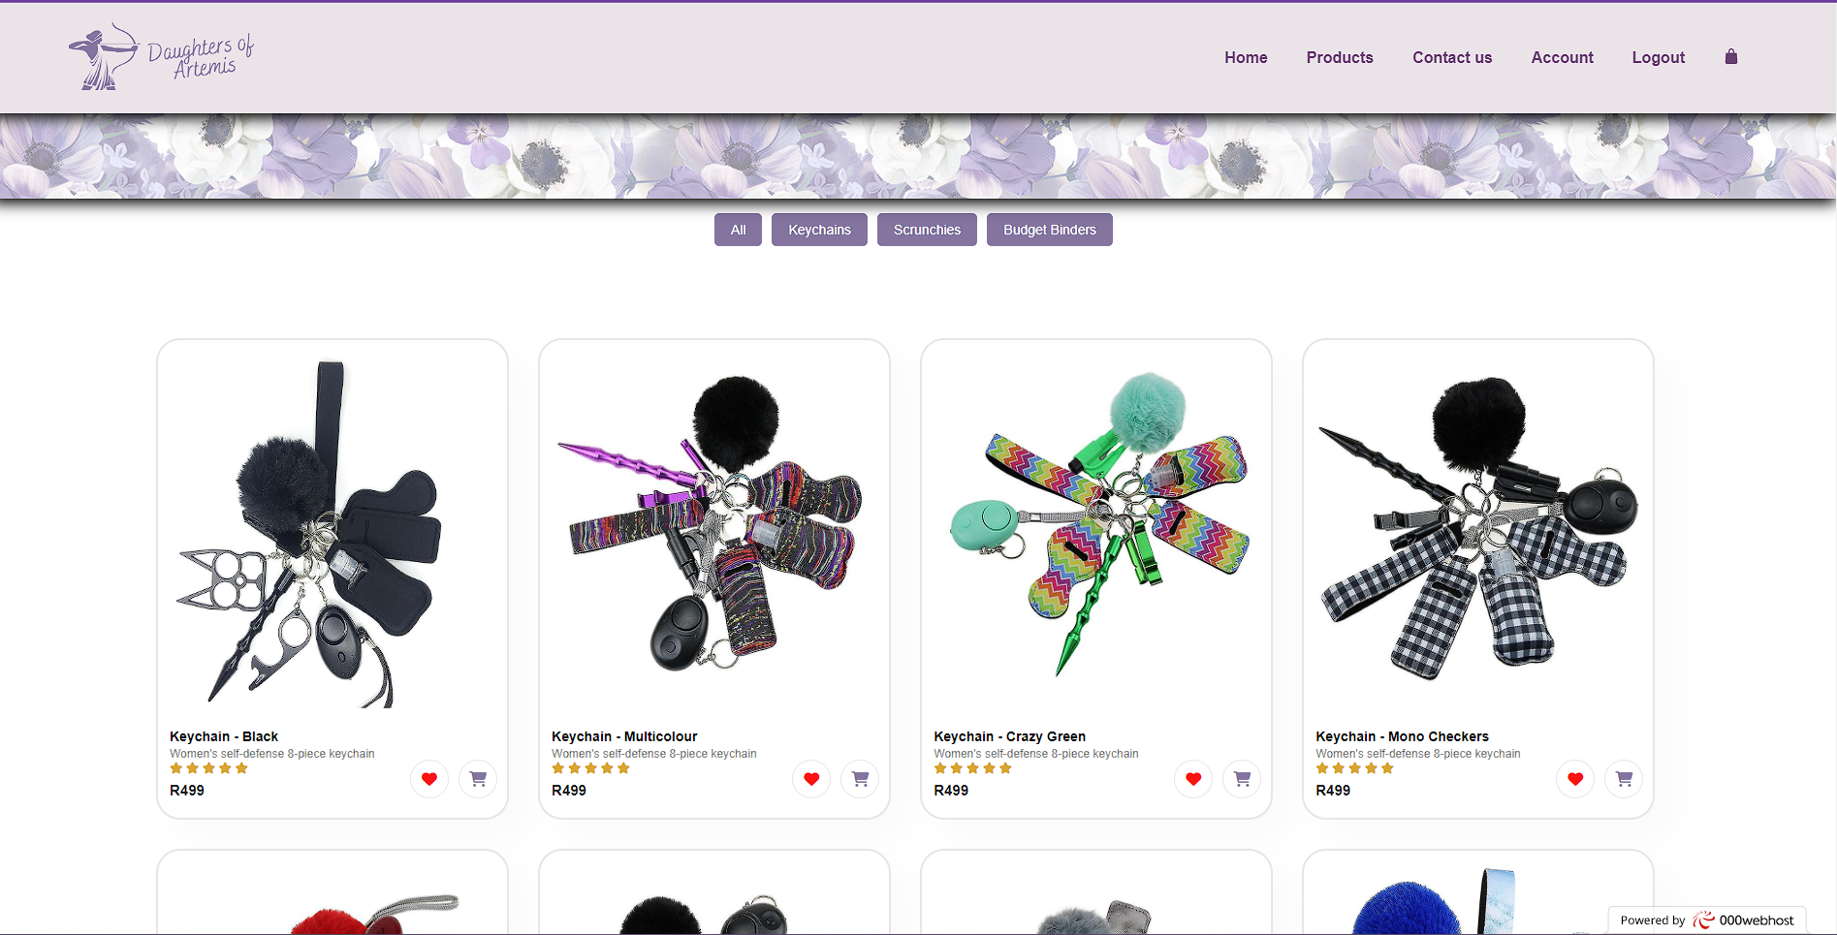

Figure 6: Customer User Menu Options



Figure 7: Admin Login Menu Options

# Shipping Options

Shipping is currently offered at a flat rate of R200 and only within South Africa.

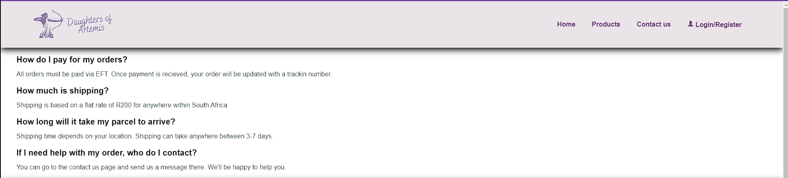

Figure 8: FAQ Page

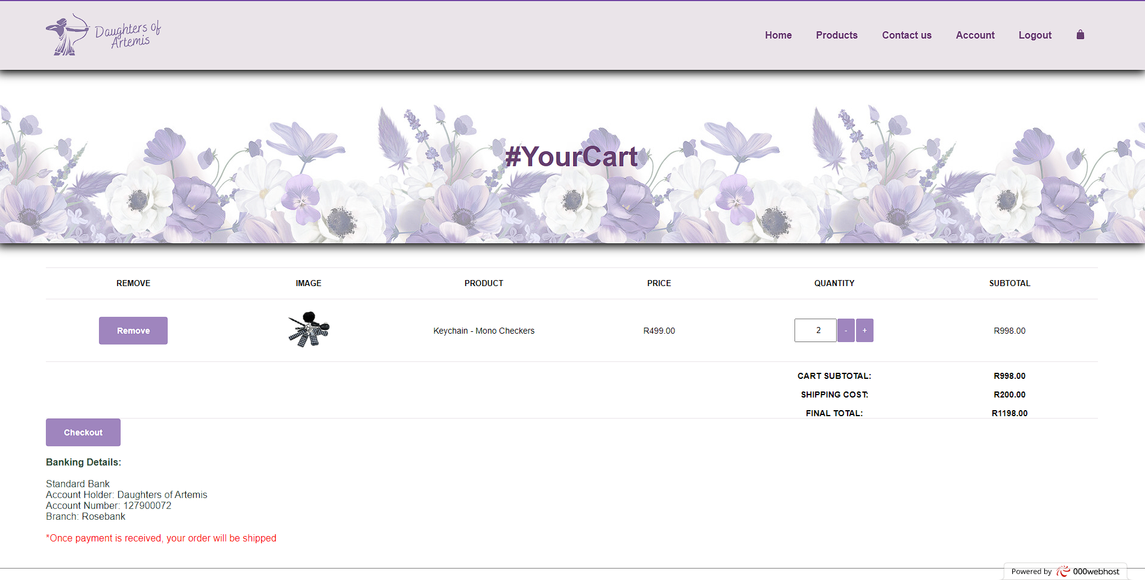

Figure 9: Cart Showing shipping cost

# Orders

For a customer to be able to place an order, they need to be signed in and have added items to their cart.

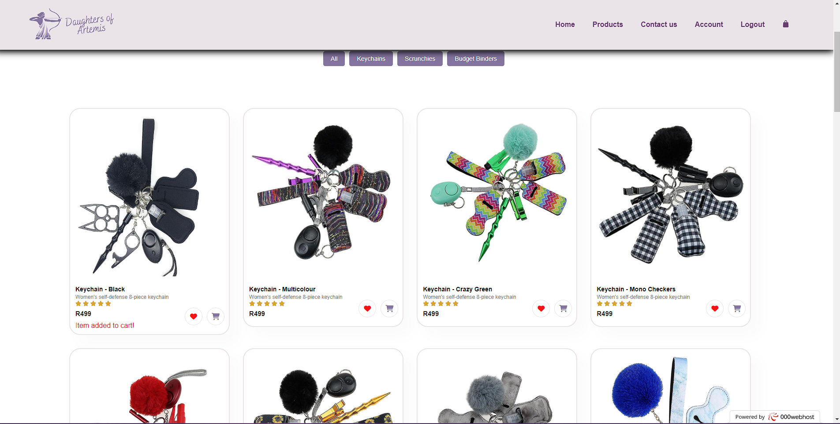

Figure 10: Products Page

Once signed in the user can click the cart button and the product will be added to their cart.

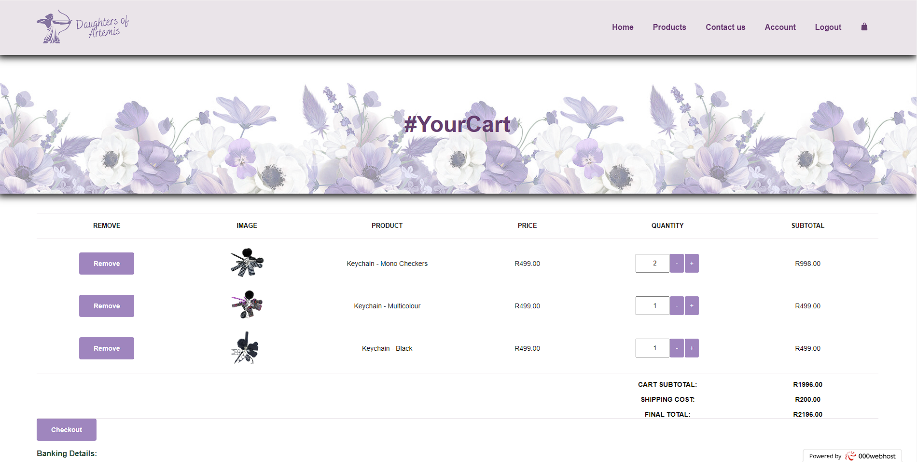

Figure 11: Cart

Customers can view their cart, edit the quantity of products, or remove the product completely.

Once the customer is satisfied and wishes to complete their purchase, they can simply click the checkout button.

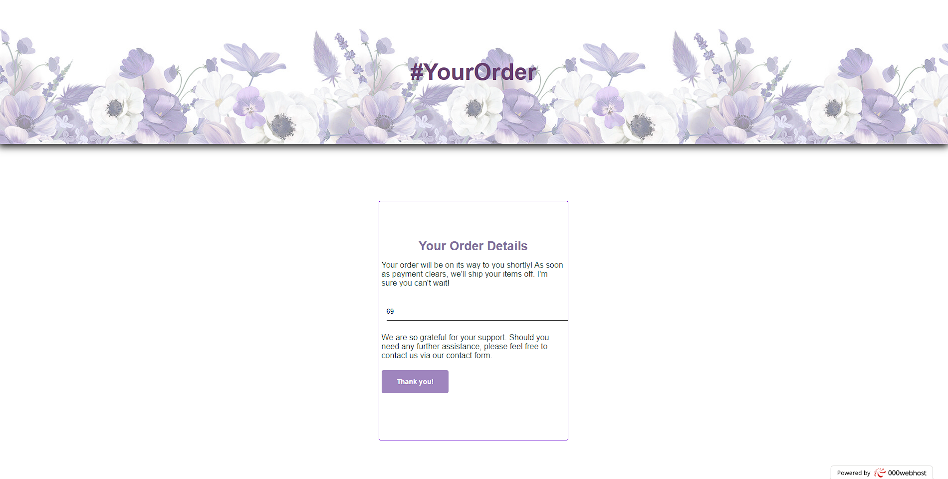

Figure 12: Order Details

From the cart, the customer will be directed to the order details page where they can view their order number. They will use this as the reference number for their order when paying via EFT. Future updates include the ability for the admin/ seller to update the users order page with their tracking number.

After clicking Thank you! They will be redirected to the home page.

Just as a side note, here we can see the order in the orders table. It was successfully stored to the database.



Figure 13: Database – Orders Table

# Updating a page on your site

Currently if the seller wants to make changes to their website, they will need to contact the developer. They are only able to make changes to the products listed on their website.

# Collecting money from the store

The only payment method offered presently is EFT. Once the customer completes their order, they will receive an order. They can use this as their reference when paying via EFT. Once the payment clears in the clients’ bank account, the order will be processed and shipped.

In future updates, we will include the functionality for the client to update her customers with a tracking number via email and via their account page.

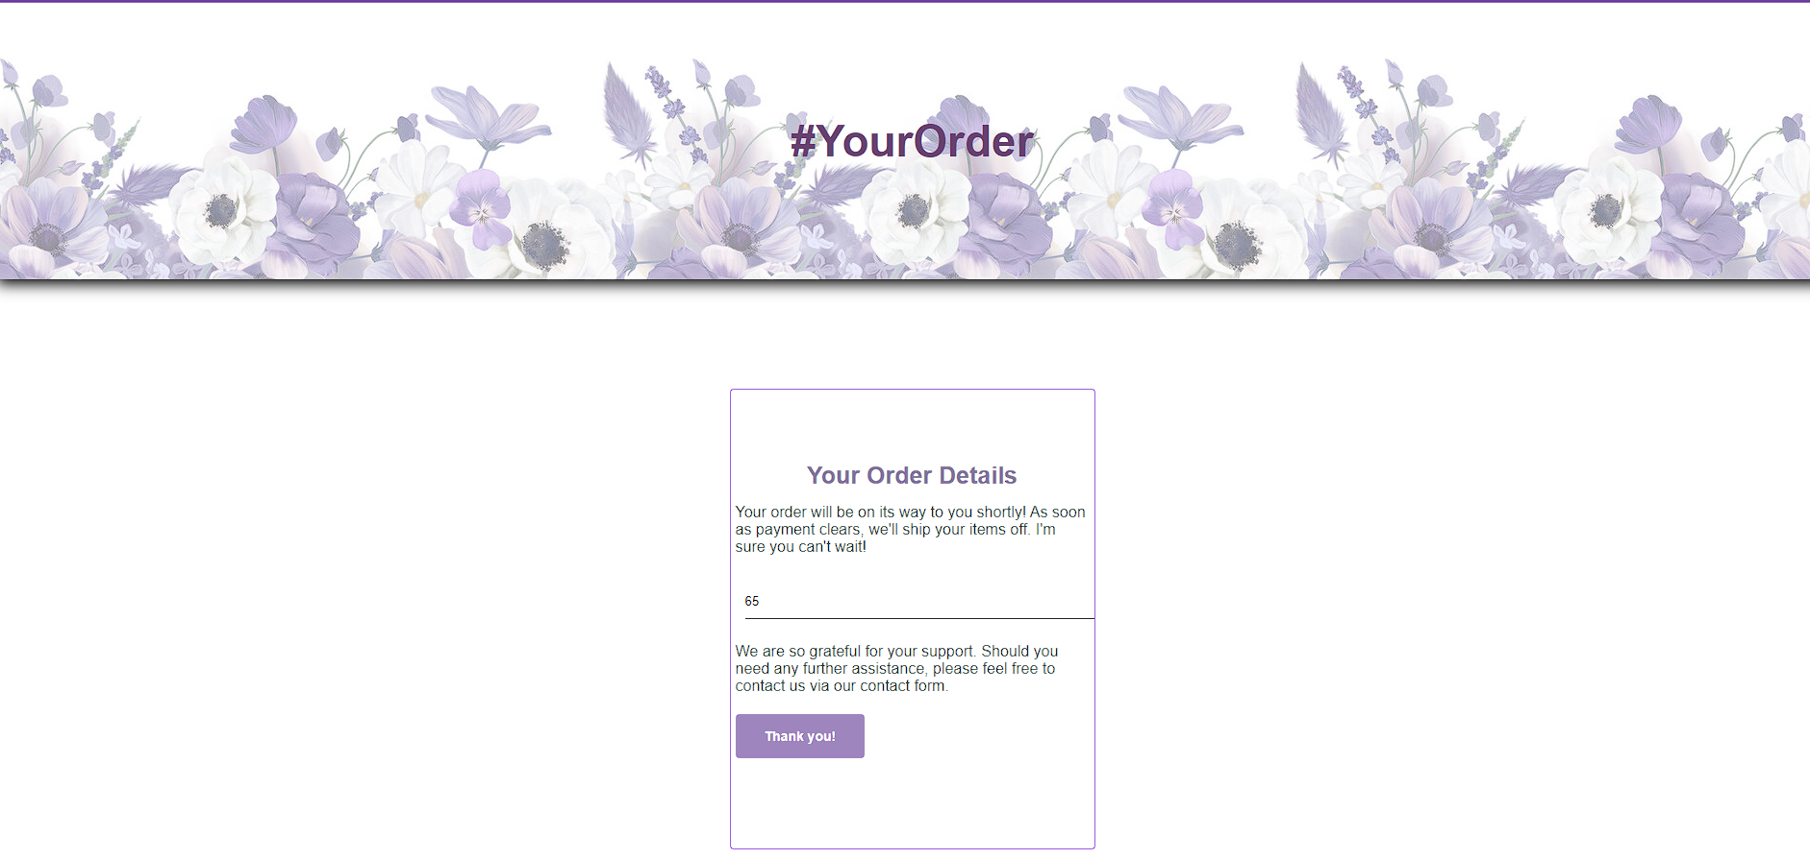

Figure 14: Order Details – order number

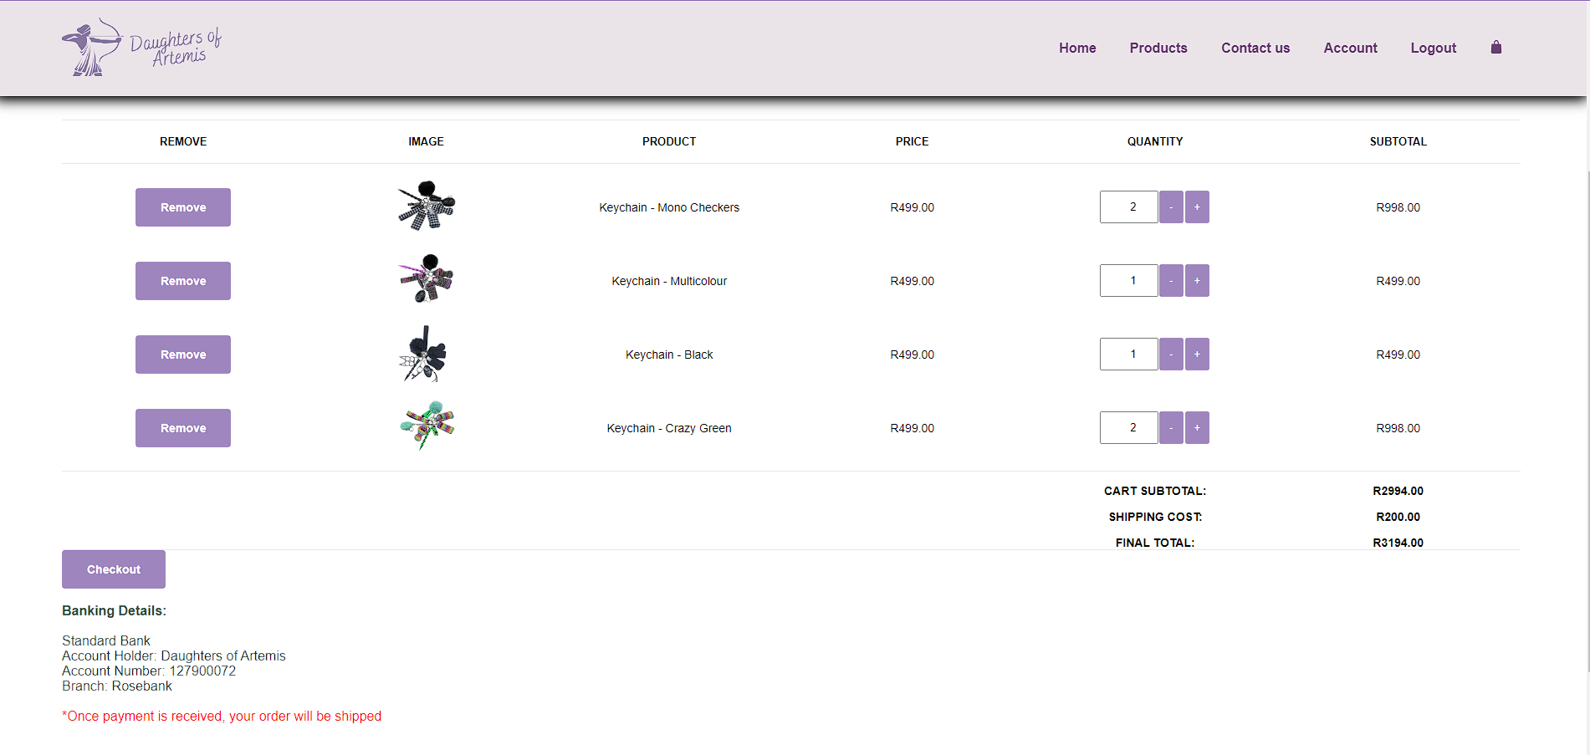

Figure 15: Banking details

# Checking Web Traffic and Statistics

000webhost allows for Google Analytics to be installed on the website. It is not currently installed.

This is what is currently available:

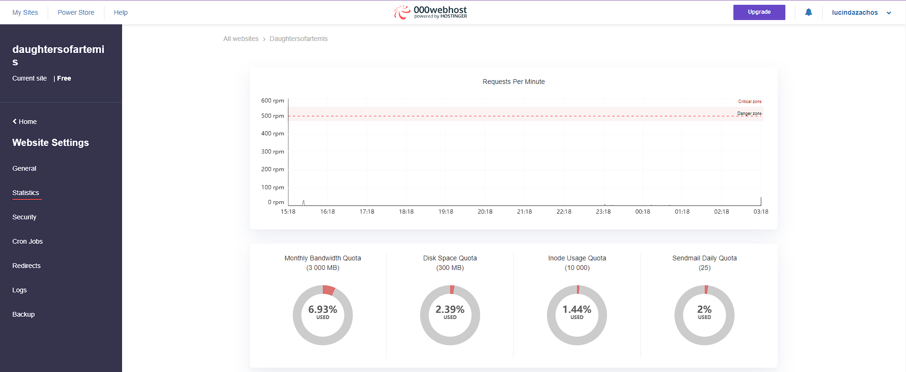  
Figure 16: Request per minute

# Appendix

How the website can be setup:

1. Ensure you have the daughtersofartemis project folder stored on your computer.
2. Navigate to the [https://www.000webhost.com](https://www.000webhost.com/) and create an account.
3. Once signed in, add a new website, and fill in the particulars of the website such as a name.
4. From there you can navigate to the cPanel.
5. From within the management portal you can navigate to the file manager tab and into the public_html folder.
6. There is a file called .htaccess. Open it and edit the code inside to:

**php_flag output_buffering on**

1. Ensure the home page/ landing page is named index.
2. Now upload the files within the daughtersofaretmis folder to the public_html folder.
3. If you navigate to the URL: ttps://daughtersofartemis.000webhostapp.com the website should be available.
4. Now we need to connect the database.

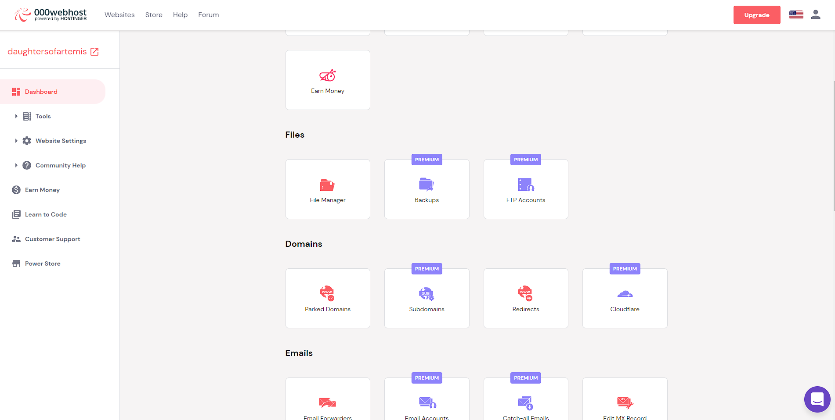

Figure 17: cPanel

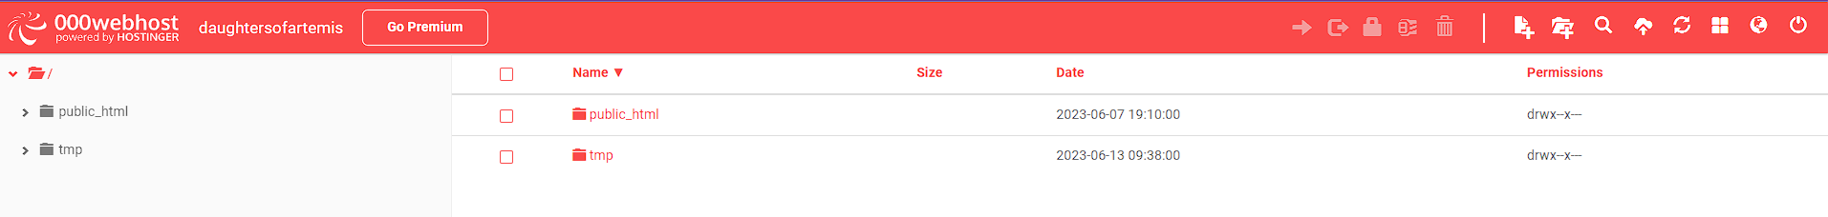

Figure 18: File Manager

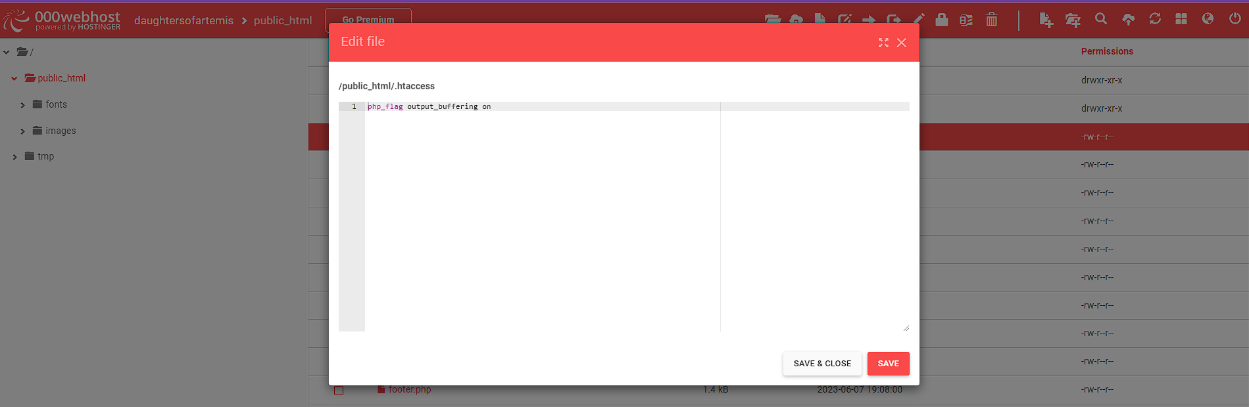

Figure 19: .htacess file

How the database can be setup:

1. From within the 000webhost cPanel navigate to phpMyAdmin.
2. Create a new database, fill in the particulars such as the databases name, username and password.
3. Open the database and navigate to the import tab and upload the Artemis database file included in the project folder.
4. Now within the cPanel > public_html file, open the dbcon.php file and edit the database name, username, and password to match the details for the new database that was just created.
5. All the products should now be visible within the website as well the product management page.

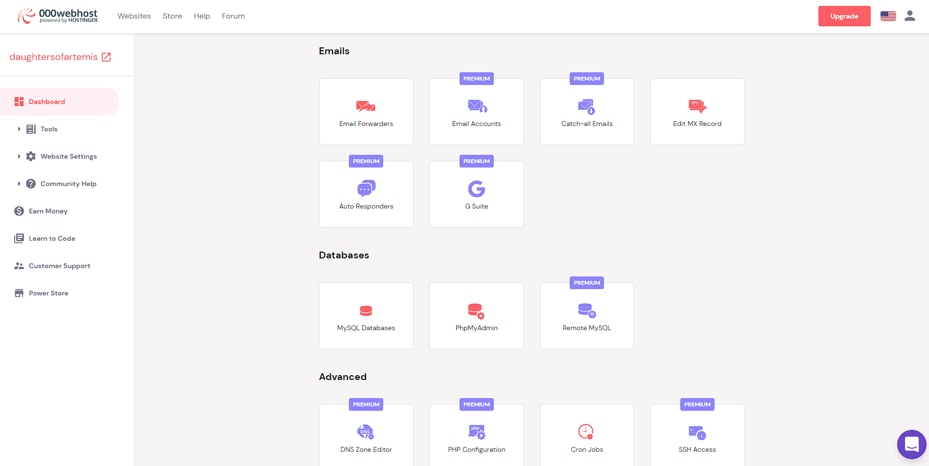

Figure 20: phpMyAdmin

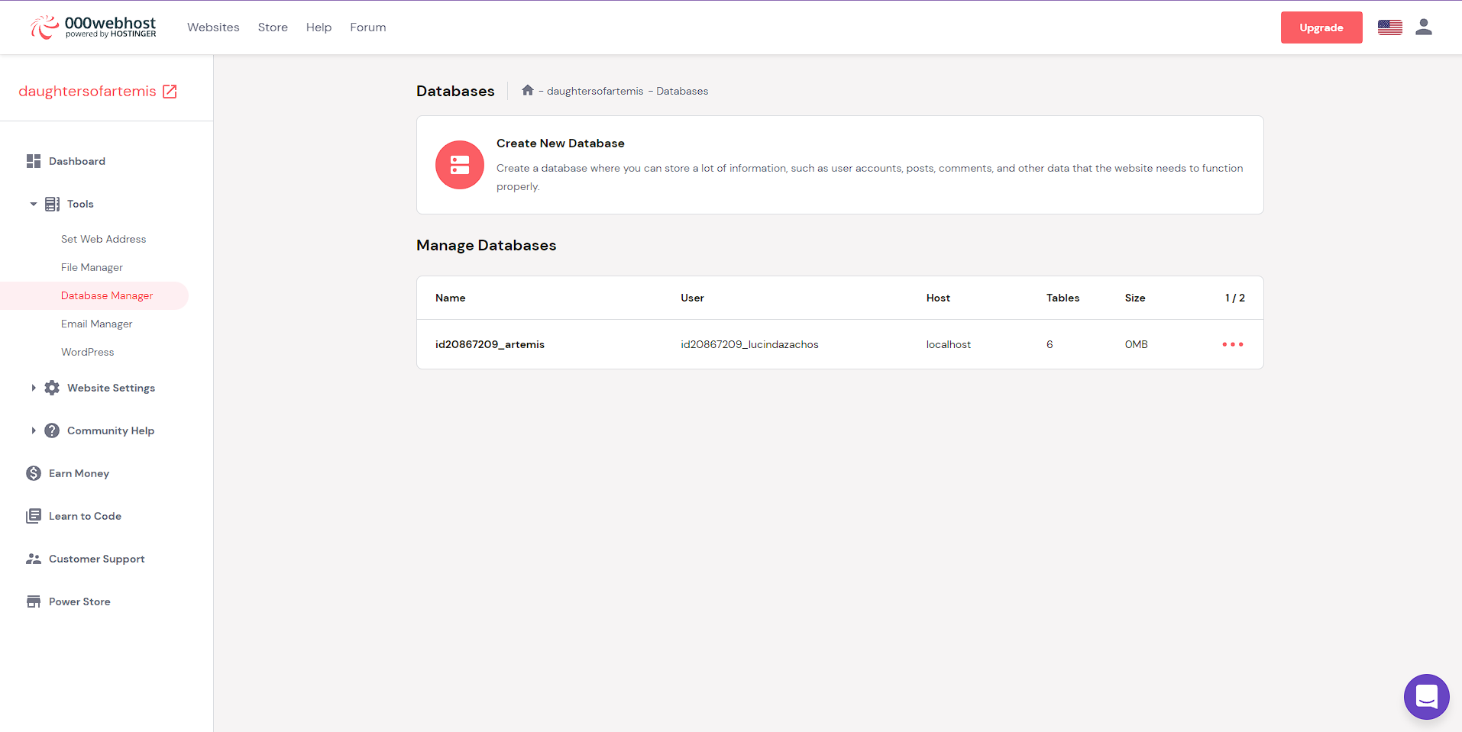

Figure 21: Database Manager – phpMyAdmin

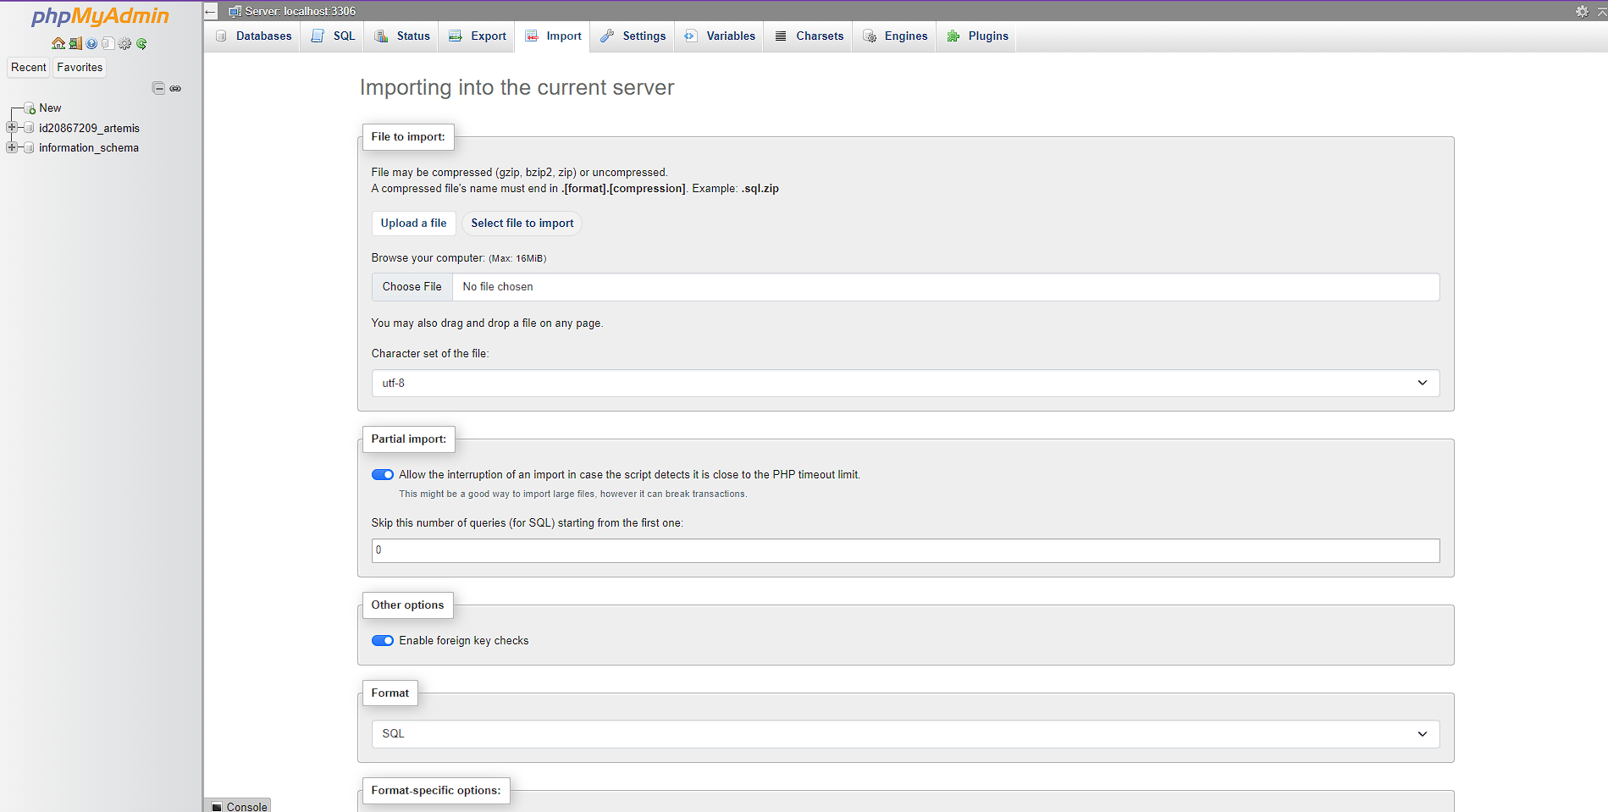

Figure 22: Database import

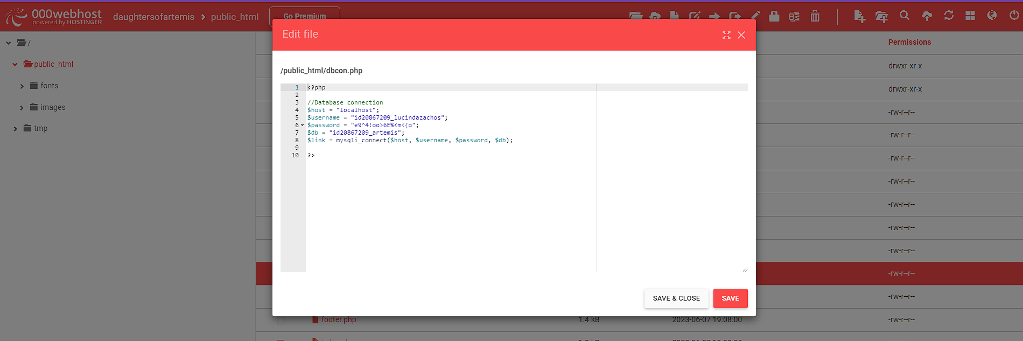

Figure 23: dbcon.php